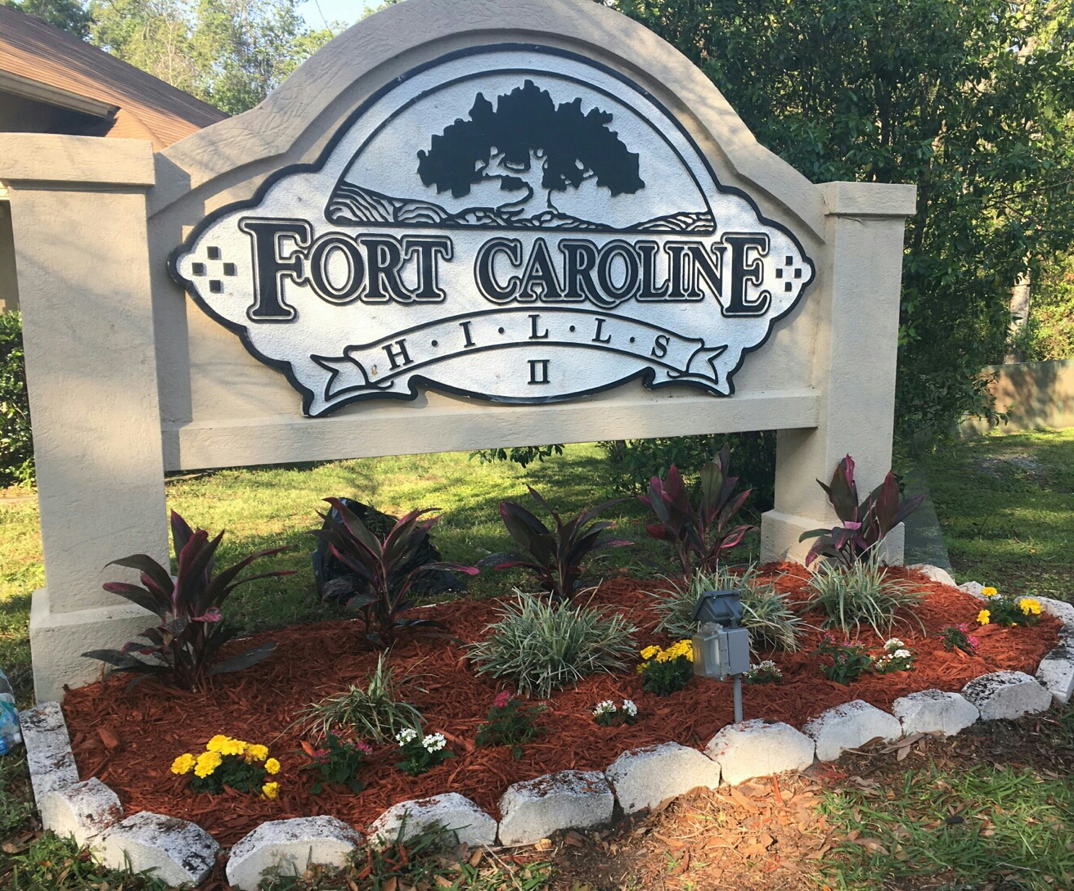  August 18, 2018  Fort Caroline Hills II HOA Meeting Minutes  - A committee has worked through 2/3 of the covenants for proposed revisions: Feedback to the proposed revisions can be made using the following link. The deadline to submit comments/suggestions is September 1, 2018.  https://docs.google.com/document/d/1LV3xWOWVkzNrDjkGj3mb26GI5j6WAl29bcWz35YfsLs/edit?usp=sharing  - A copy of the current bylaws can be found on our website.  - Yard of the month will receive a $25 gift card.  - New Lawn Service provider is “A. Norman.”  - Sprinkler System Repair quotes are being obtained by T. Huger.  - Financial Report is available upon request.  - Plans are still underway to secure a mangement company for the HOA once the By-Laws have been revised & sprinkler system repaired. Quarterly meetings will still be required once the management company has been secured.  You can contact us: www.fcha2.org  Facebook: Fort Caroline Hills II HOA  P.O. Box 11987, Jacksonville, FL 32239  Next meeting #3 to review the bylaws is September 22 | Proposed By-Law Revisions  Three major sets of suggested changes:  Remove/replace the developer language and apply the Association in its place where appropriate  Address the changes to community rules and requirements discussed at the Spring HOA meeting  Clearly outline process and protections for homeowners and the association  By-Law Reminders  Pick up behind your pet to keep our neighborhood environmentally safe  ────  No parking on common grounds. The repair of sprinkler heads will be the homeowner’s responsibility  ────  Cars parked on the street should not obstruct traffic  ────  No commercial vehicles (trucks) are allowed to be parked in the neighborhood  ────  Thank you for making Fort Caroline Hills II a great place to live!

