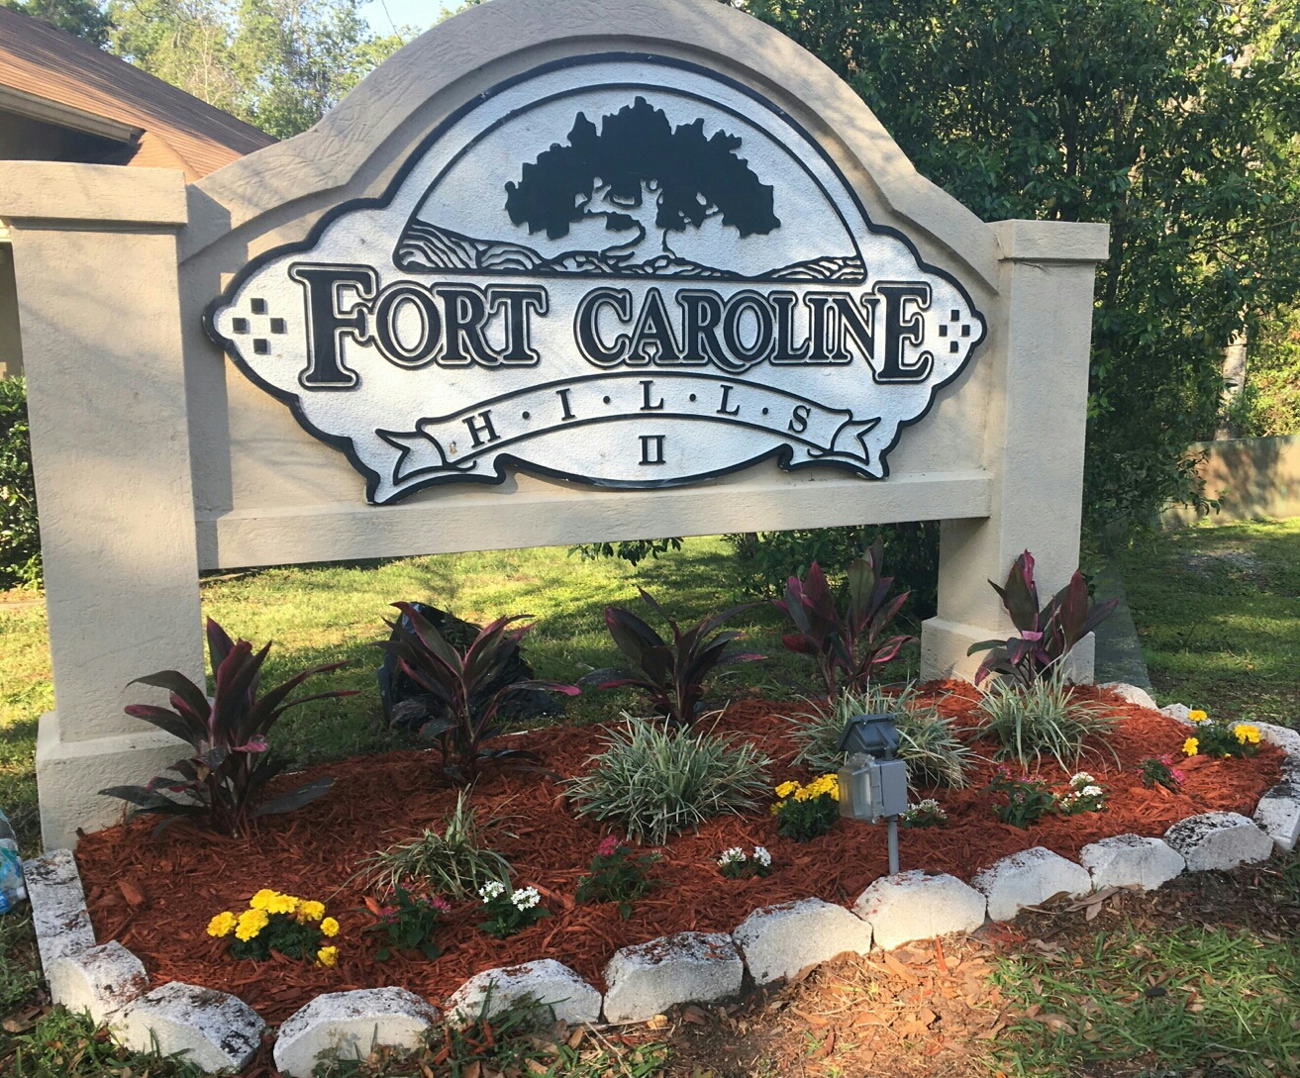  May 8, 2018  Fort Caroline Hills II HOA  Keeping You Updated!  Thank you for attending last Saturday’s HOA meeting! The focus of the meeting was to revise the current bylaws that govern our association. A copy of the current bylaws can be found on our website. Here are a few reminders that are incuded in our bylaws.  You can contact us to share your suggestions!  - www.fcha2.org  - Facebook: Fort Caroline Hills II HOA  - P.O. Box 11987  Jacksonville, FL 32239  Next meeting #2 to review the bylaws is July 7th | Keep your property maintained and free from overgrown weeds & bushes near the roadway  ────  If you are renting, please provide the HOA a copy of your lease (this allows occupants and owners to stay updated)  ────  Pick up behind your pet to keep our neighborhood environmentally safe  ────  No parking on common grounds. The repair of sprinkler heads will be the homeowner’s responsibility  ────  Cars parked on the street should not obstruct traffic  ────  Sheds must be hidden from view behind a fence  ────  No commercial vehicles (trucks) are allowed to be parked in the neighborhood  ────  If you have trees cut down, you are responsible for making sure the street is cleaned. Please make sure leaves are not blown into the street as this backs up the drainage!  Thank you for making Fort Caroline Hills II a great place to live!

